2nd International Multidisciplinary Conference on Emerging Trends in Engineering Technology-2024 (2nd IMCEET-2024)

**A Designed Energy Management System (EMS) for an Off-Grid Residential Microgrid**

Olivier Kiraga Cyubahiroa, Martial Giranezaa,*, Khaled Abo-Al-Eza, Mohamed Tariq E. Kahna

a *Centre for Distributed Power and Electronic Systems, Cape Peninsula University of Technology, Bellville 7535, Cape Town, South Africa*

* Corresponding author: Martial Giraneza, Email: [giranezam@cput.ac.za](mailto:giranezam@cput.ac.za)

|  |  |  |
| --- | --- | --- |
| K E Y W O R D S |  | A B S T R A C T |
| Photovoltaic system  Wind system  Battery  NnnMicro-grid  State machine  Energy Management  Supply-demand balance |  | This paper proposes an Energy Management System (EMS) of an off-grid residential microgrid comprised of a solar photovoltaic array, wind turbine, and a battery-based energy storage system for a residential building in a remote area. The aim is to design a less complex energy management system that addresses energy resources dispatch challenge in a hybrid residential microgrid. It equitably dispatches resources and manages the generated energy to meet the residential load. The management control system algorithm is implemented using the state machine and simulated in MATLAB/Simulink environment for validation. Three scenarios are simulated, they emulate various contingencies scenarios that might rise due to the intermittency nature of the renewable resources. Simulation results show that the proposed energy management system achieves its design objectives. It maintains the power supply and demand balance, through an appropriate scheduling of resources even during contingency due to the intermittence nature of the renewable resources. |

**1. Introduction**

Access to energy in rural and urban areas is a challenge in developing countries. The reliability of power supply in electrified areas and environmental awareness opens the door for microgrids. The microgrid concept is established as an alternative solution for electrification for remote areas and as a platform for renewable energy integration in urban and suburban networks. Microgrids are defined as a cluster of loads and power generating units operating as a single controllable system with the ability to be connected or not to a grid [1]. Environmental concern and energy security are the main motivations for microgrids concept development [2]. The decarbonisation of the energy production approach to address environmental concerns sets up space and opportunity for microgrids to flourish [3]. Furthermore, the microgrid concept has proved to be an economical alternative to the traditional top-down grid extension for remote areas and improved the reliability of energy supply in urban areas. In addition, it provides the opportunity to cut the cost of energy in urban areas while relieving the pressure off the traditional grid. The early application of microgrids was in data centres, military bases and remote rural areas. Microgrids can be classified as grid-connected or off-grid depending on their mode of operation. They can also be classified as DC or AC microgrids depending on the nature of generated current. Microgrids are also classified according to the beneficiaries or end-users. Thus they can be residential microgrids for one household or community microgrids for the entire community. A residential microgrid usually consists of a generation unit or facility, the power conditioning equipment and residential loads, and the grid integration interface for grid-connected operation. Justo et al. have presented a comparison of both systems and analyzed multiple aspects of microgrids benefits. Microgrids can be based on single or multiple renewable technologies. The latter is also referred to as a hybrid microgrid. It has higher reliability than a single technology microgrid, which is limited by the intermittence nature of the renewable source. Thus, hybrid microgrids are characterized by different renewable energy resources, technologies and an energy storage system for an increased power supply reliability. Furthermore, diesel generators can also be associated with a microgrid to form a high reliable hybrid microgrid system immune to the effects of renewable resources intermittently.

Nevertheless, the benefits mentioned above of a hybrid microgrid system come with challenges: managing various intermittent resources to match the demand. Thus the control strategy, energy and power management schemes are critical aspects for hybrid microgrid operation. The power management deals with operational regulation and interface parameters for each source within the microgrid, while energy management deals with the optimal matching of the load to the available, total power production. In microgrids, the energy management system relies on control strategies software to achieve optimal resources.

Various authors reported on different strategies in regards to the energy management system in hybrid microgrids. A comparative analysis of energy management systems is presented in; the authors compared three dispatch strategies for a hybrid energy system consisting of renewable resources, a diesel generator and an energy storage system. The three strategies are cycle charging, peak shaving and load following. They found that the cycle charging strategy was cost-effective. Olatomiwa et al. presented a comprehensive review on energy management strategies in hybrid renewable energy. They analyzed various techniques and strategies used in isolated and grid-connected microgrids. The review scoped the popular approaches into linear programming and artificial intelligence approach, energy management on linear programming or artificial intelligence for a standalone and grid-connected microgrid. It was concluded that the best approach depended on the context and type of renewable energies involved. In a linear programming based energy management system is presented for an islanded hybrid microgrid. The developed algorithm aimed at maintaining the supply-demand balance within the microgrid. An energy management system based on a hybrid automata algorithm and a propositional-based logic is presented in for an islanded microgrid.

Most authors focused on energy management systems for application in grid-tied residential microgrids with enhanced features such as energy prediction, which rely on communication, thus rendering the system complex and expensive for application in off-grid rural areas. Therefore, this paper proposes a simple, reliable and affordable algorithm for an EMS for an off-grid residential microgrid in rural areas. The system is less complex and operates based on the current status of the available resources and the residential demand, with no need for communication. The paper is organized as follows: Section 2 describes the residential microgrid. Section 3 covers the proposed energy management system for the microgrid. Section 4 presents the simulation results, and Section 5 concludes the paper.

**2. System Description**

The proposed algorithm for the energy management system is applied to a residential off-grid microgrid. The latter consists of a photovoltaic unit (PV), a small wind turbine, an energy storage system (battery bank) and the load. The loads are categorized into three categories: AC, DC, and dump load for energy excess cases. The hybrid microgrid is configured as shown in Fig. 1, and a DC network is used to integrate the renewable resources. Power electronic interfaces are used for wind and PV and AC load interconnection to the DC bus. The PV and wind operate as the primary sources to supply the house loads (AC and DC). A battery-based energy storage is used to mitigate fluctuations in energy from the intermittence nature of the primary sources. The overall sizing of the microgrid was done using Homer software.

*2.1 Photovoltaic System*

The PV system is developed around photovoltaics cells, represented by its equivalent diode model shown in Fig. 2. It consists of a current source and a PN junction parallel with a shunt resistor Rsh and series resistor Rp. The series resistance represents the ohmic losses which occur through the electrical contacts and the resistivity of the cell material, the shunt or parallel resistance Rp is equivalent of the losses in the junction, the Id is the diode current when forward biased, Iph the photocurrent generated current by the cell due to the solar irradiation. I is the output current at the terminals of the solar cell, expressed by equation (1). In the above equation, A is the ideality factor of the diode, and VT is called thermal voltage, V is the voltage imposed on the diode, I0 is the leakage are okay.

*2.1.1 Photovoltaic system*

The PV system is developed around photovoltaics cells, represented by its equivalent diode model shown in Fig. 2. It consists of a current source and a PN junction parallel with a shunt resistor Rsh and series resistor Rp. The series resistance represents the ohmic losses which occur through the electrical contacts and the resistivity of the cell material, the shunt or parallel resistance Rp is equivalent of the losses in the junction, the Id is the diode current when forward biased, Iph the photocurrent generated current by the cell due to the solar irradiation. I is the output current at the terminals of the solar cell, expressed by equation (1). In the above equation, A is the ideality factor of the diode, and VT is called thermal voltage, V is the voltage imposed on the diode, I0 is the leakage are okay.

**3. Simulation and Results**

To test and validate the performance of the proposed energy management system algorithm, MATLAB/Simulink software environment is used. The residential microgrid load, parameters and renewable resources data modelled and used as a benchmark to test and validated the energy management system are adapted from.

*3.1 Parameters*

As shown in Fig. 3, the system comprises of wind and PV systems that supply the power together to sustain the load demand; it also has a battery-based energy storage system. The energy management system controls the battery cycle through switches. The total load consists of AC, DC and dump loads, and the proposed energy management system controls their respective switching in and out from the supply.

The PV model used in this paper is a Soltech PV model and it is a fixed model; the Soltech PV model (and parameters) is available in the Simulink. Therefore, the system is coupled with Maximum Power Point Tracking system known as MPPT, with a Perturb and Observe (P&O) algorithm to extract the maximum possible power from PV. Table 1 shows the parameters of the photovoltaic module used in this system, they are adapted from.

The PV model used in this paper is a Soltech PV model and it is a fixed model; the Soltech PV model (and parameters) is available in the Simulink. Therefore, the system is coupled with Maximum Power Point Tracking system known as MPPT, with a Perturb and Observe (P&O) algorithm to extract the maximum possible power from PV. with a Perturb and Observe (P&O) algorithm to extract the maximum possible power from PV.Table 1 shows the parameters of the photovoltaic module used in this system, they are adapted from.

The PV model used in this paper is a Soltech PV model and it is a fixed model; the Soltech PV model (and parameters) is available in the Simulink. Therefore, the system is coupled with Maximum Power Point Tracking system known as MPPT, with a Perturb and Observe (P&O) algorithm to extract the maximum possible power from PV. with a Perturb and Observe (P&O) algorithm to extract the maximum possible power from PV.Table 1 shows the parameters of the photovoltaic module used in this system, they are adapted from.

The PV model used in this paper is a Soltech PV model and it is a fixed model; the Soltech PV model (and parameters) is available in the Simulink. The wind model used in this study is a Permanent Magnet Synchronous Generator (PMSG) with 230V, 5kW, and 50Hz. Table 2 shows the parameters of the wind system used as adapted from [28]. The chosen energy storage system is a Lithium-Ion battery based system. Two-rows of 19 Lithium-Ion batteries are connected in series, each with 12V and 20Ah, which gives a total of 228V, 20Ah, and an overall 9120 Wh. Table 3 shows the parameters of the battery-based energy storage system used in this study as adapted from.

**Table 1**

Photovoltaic input parameter

|  |  |
| --- | --- |
| Photovoltaic Model input parameter | Value |
| Module | 1Soltech-230 |
| Maximum Power (W) | 228.735 |
| Open Circuit Voltage Voc (V) | 37.1 |
| Voltage at Maximum PowerPoint (V) | 29.9 |
| Short-circuit current ISC (A) | 8.18 |
| Current at maximum power  point Imp (A) | 7.65 |
| Temperature coefficient of  Voc (%/oC) | 0.102 |
| Cells per module (NCell) | 60 |

The PV model used in this paper is a Soltech PV model and it is a fixed model; the Soltech PV model (and parameters) is available in the Simulink. Therefore, the system is coupled with Maximum Power Point Tracking system known as MPPT, with a Perturb and Observe (P&O) algorithm to extract the maximum possible power from PV. Table 1 shows the parameters of the photovoltaic module used in this system, they are adapted from. The PV model used in this paper is a Soltech PV model and it is a fixed model; the Soltech PV model (and parameters) is available in the Simulink.

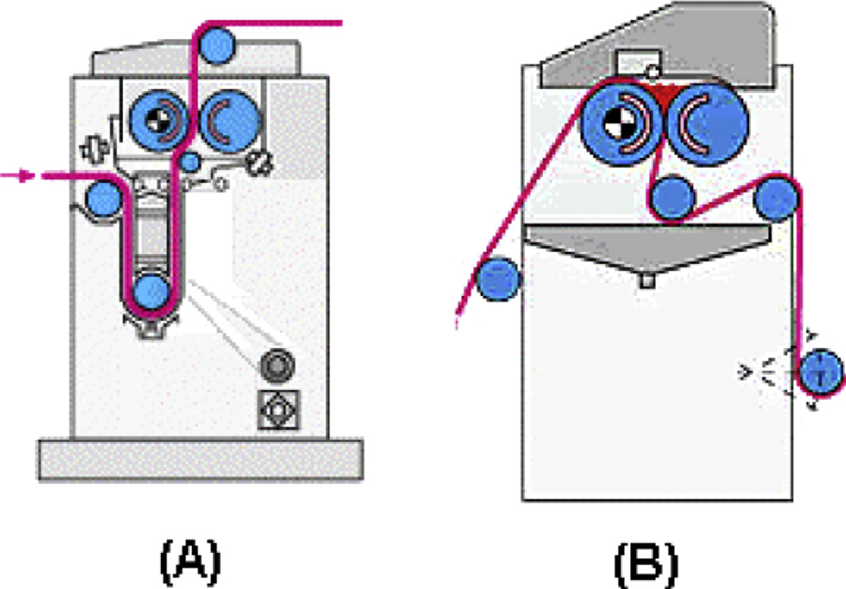

**Fig. 1.** Representation of a U-shaft (A) and nip (B) dye liquor application systems

**4. Conclusion**

The energy access is a challenge for rural community and renewable energy based hybrid residential microgrid emerged as a viable solution. However, the management of these resources requires an energy management system. Thus, this paper proposed an energy management system algorithm for a residential hybrid microgrid system. The later consists of a photovoltaic system (PV), wind turbine, and a battery based energy storage system. The proposed energy management aims at an equitable dispatch of the available power from the renewable resources; and at the same time implement various scheme during contingency that might rise due to the intermittence nature of the renewable energy resources. For testing and validation the system is simulated over a residential off-grid microgrid model developed in Matlab/Simulink environment. Three scenarios are tested , they emulate the normal condition, sudden load increasing combined with a fluctuation in the renewable power resource ; and a complete loss of one resource. The results show that the proposed energy management system, successfully manages the supply and the demand balance within the microgrid. It shows its ability to perform an adequate power resources dispatching during renewable resource energy fluctuations, through the control of energy storage system cycles. By the battery cycles control, the proposed energy management system protects the battery system from overcharging damages. Unlike others systems as presented in the introduction, the energy system presented in this paper is less complex, economic and easy to upgrade. The proposed system can be applied to grid connected or in peer to peer energy trading.

**5. Reference**

[1] A. K. Jhatial, A. Khatri, S. Ali, and A. A. Babar, “Sol–gel finishing of bamboo fabric with nanoparticles for water repellency, soil release and UV resistant characteristics,” *Cellulose*, vol. 26, no. 10, pp. 6365–6378, 2019, doi: 10.1007/s10570-019-02537-3.

[2] A. Khatri and M. White, “Sustainable dyeing technologies,” in *Sustainable Apparel*, R. Blackburn, Ed. Woodhead Publishing, 2015, pp. 135–160.

[3] S. Ali, Z. Khatri, A. Khatri, and A. Tanwari, “Enzymatic processing of cotton towel for water and thermal energy conservation,” in *Third International Conference on Energy, Environment and Sustainable Development*, 2014, p. 73.